DEMON
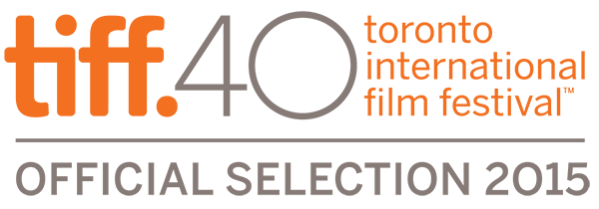
A film by Marcin WRONA
94 min, Poland - Israel, 2015
Color, HD & DCP
Polish, English, Yiddish

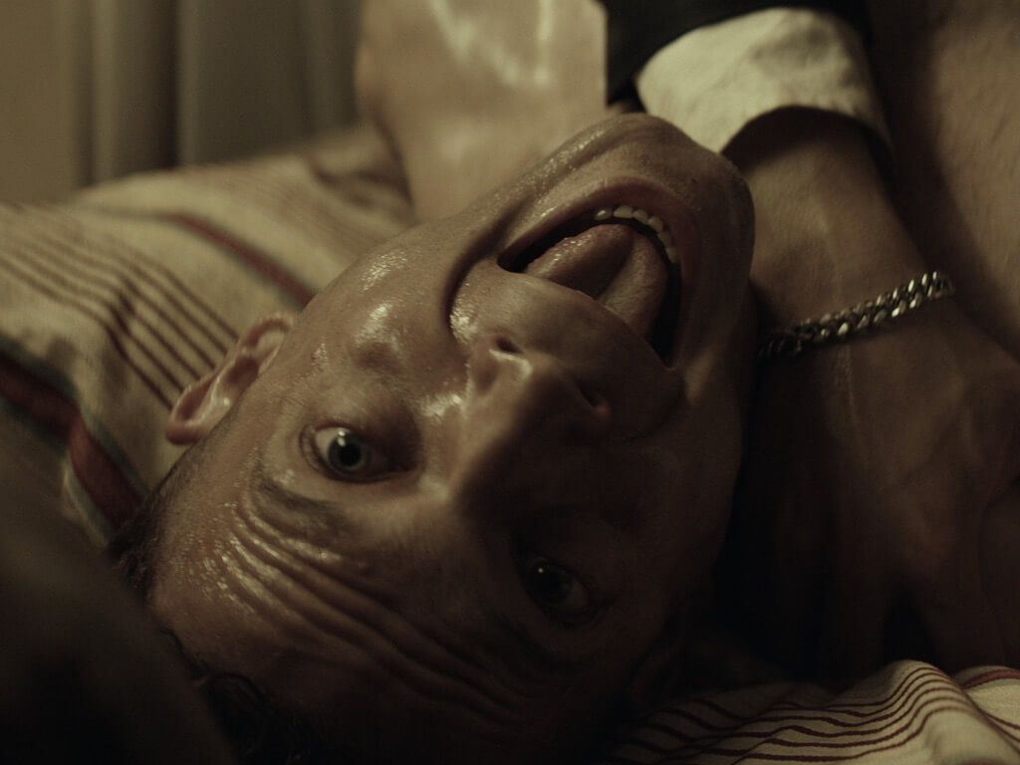

SYNOPSIS

A young man is a stranger visiting the hometown of his future wife. As a wedding gift from the bride's grandfather, he receives a piece of land where the two can build a house and raise a happy family. While preparing the land to build the house he finds the bones of human bodies in the ground beneath his new property. Strange things begin to happen to change this happy couple's lives forever.

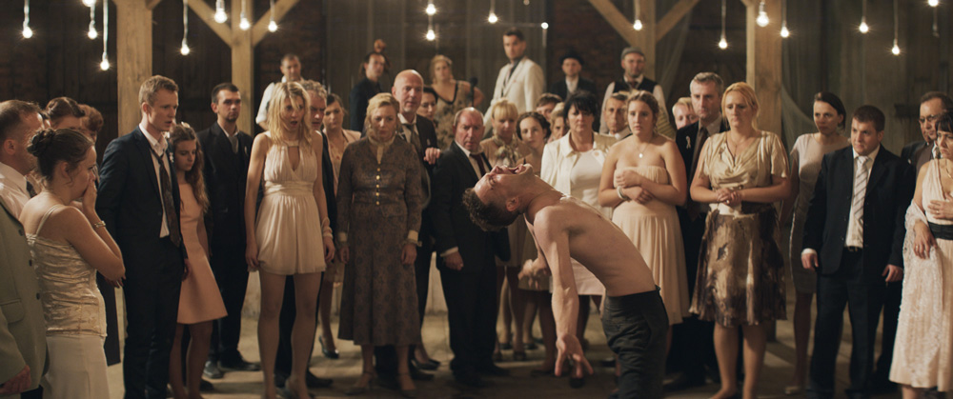

CAST

ITAY TIRAN
AGNIESZKA ŻULEWSKA
TOMASZ SCHUCHARDT
TOMASZ ZIĘTEK
ADNRZEJ GRABOWSKI
WŁODZIMIERZ PRESS
ADAM WORONOWICZ

DIRECTORS’S BIOGRAPHY & FILMOGRAPHY

Born in Tarnow in 1973. Graduate of Film Studies at the Jagiellonian University adn Film Directing at the Radio and Television Department of the University of Silesia. As well as the Andrzej Wajda Master School of Directing and The Binger Film Institute in Amsterdam. Winner of mutliple awards for his student debut "Magnet Man" (2001). Other films include: "My flesh my blood" 2009 ( Rome FF) and "The Christening" (2010) Toronto IFF, San Sebastian IFF

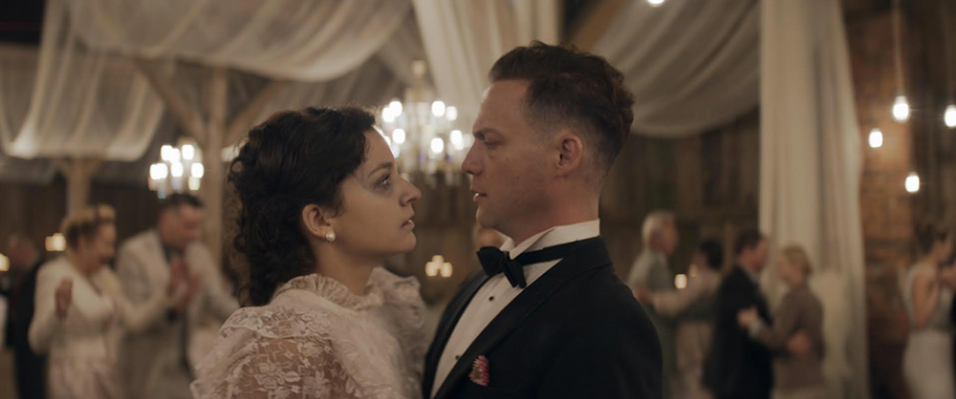

PRODUCTION COMPANY

Producer Magnet Man Film Ltd.
ul.Walecznych 18/1 03-916 Warsaw
Poland

Lead Producer Marcin Wrona
ul.Walecznych 18/1 03-916 Warsaw
Poland

Main co-producer Transfax Film Production
Israel

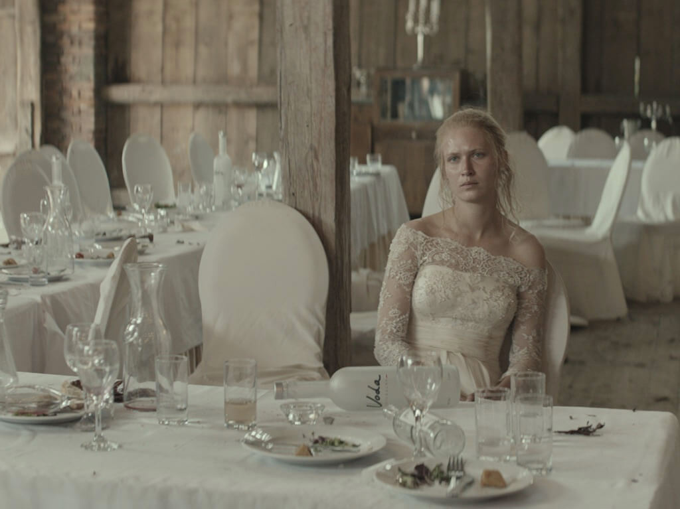
CREW

Design & Direction MARCIN WRONA
Story / Screenplay MARCIN WRONA & PAWEŁ MASLONA
Director of Photography PAWEŁ FLIS
Music KRZYSZTOF PENDERECKI & MARCIN MACUK
Sound TOMASZ SIKORA
Editor PIOTR KMIECIK
Producers MARCIN WRONA
Production Design ANNA WUNDERLICH
Costume Designer ALEKSANDRA STASZKO

DIRECTOR’S STATEMENT

“What's most important to me in this film is the tale of spirituality, which is now very difficult to access or it has completely changed its face. What we tried to achieve in this film was for the wedding guests to be confronted by something supernatural. They don't know how to act on it or how to communicate with it. We have used grotesque horror in our film, but our aim wasn't to copy Japanese or Spanish or American horror films, they have their own demons, we wanted to use ours.

The title DEMON was chosen very deliberately too. In fact we meant the dybbuk not the demon. But since the latter is rather forgotten nowadays we decided to use a contemporary word that most of our wedding guests would use. Dybbuk was very present in Poland when the Jewish community here was still very numerous. Once they left the land so did the dybbuks. Demon is different than dybbuk.

Dybbuk doesn't have to be scary. It's a returning soul which returns not to scare away but rather to remind us of respect for tradition. And that is what we were trying to achieve with our film. I didn't want in any way for the film to be about the Holocaust. I wanted to touch the mystic aspect of the Jewish-Polish lives and hence the idea to cast an Israeli actor in our film.”

Marcin Wrona / 2015

ABOUT THE PRODUCTION

VISUAL STYLE

“The visual idea for this film was that we shoot it like old photographs, we wanted the shots to look like stills and tell the story using wide lenses and make the shots look wide, we didn't want the camera to move a lot.

I like to keep a very small distance between the actor and the camera, but at the same time the camera is an observer, it doesn't interfere. We used one Alexa camera only, it's my first film on this digital camera and I was so amazed at how it works with the picture, I loved it! You can take out so much from it in post –production too and as Marcin said, the scenes look like they were shot for a Western.”
Pawel Flis / Director of Photography

THE LOCATION

“I wanted the time and place of the film to be universal. 20th century, somewhere in Poland, without being precise” said Marcin Wrona. “The film was meant to draw us back to classic cinema. I wanted to make it look traditional in composition and not to have any special effects or super modern technologies used. A lot of photographic style, as if someone with great taste had been taking photos (static takes) from the wedding.

Finding the perfect location, where 90% of the shooting was supposed to take place was extremely hard. Together with Anna Wunderlich - our production designer- we drove through three different regions of Poland for three months, based on our own knowledge and also photo albums with old monuments. Unfortunately most of the buildings we found were either in a sorry state or renovated in a very kitschy way. What was equally hard was finding the space of the house that was needed for us to fit a whole wedding.

After about two and a half months we stopped looking for a house and we found a great place where we could build it instead. And then totally out of the blue we found the perfect place - a house from 1890 with a huge barn from back then. Renovating the entire thing cost us a lot of money and work but gave the film a unique character and made the entire team feel special working for months in the mud and rain.”

Zuza Hencz / Post Production Mgr.

THE LOOK OF THE FILM

In March of 2015 the filmmakers consulted with Justine Wright, renowned editor and recipient of the European Film Award for Best Editor on the film "Locke". DEMON was one of a very few projects invited to take part in editing workshops, organized by the European Film Academy and the Polish Film Academy. The event consisted of a lecture by Ms. Wright and then individual consultations with authors of selected projects, which has given Marcin Wrona and Piotr Kmiecik, the editor, a rare opportunity to enhance the film. Justine's remarks were included in the final cut.

”The editing of "Demon" began two weeks after we finished shooting and with small breaks it took five months” Marcin Wrona said, “The whole process of working on the picture and the sound began right after we had the first version of the film edited. In sound it gave the creators wider possibilities of thinking through the concept of how they wanted to use it in the film.

“We edited within the frame and shot with wide lenses to make the scenes look wide in picture. The camera was not supposed to move a lot. As we shot the film and saw how beautiful the production set was and the great costumes the actors had and the choreography they used we knew that it was impossible to keep the camera still. So we changed our original idea so that the film would become better.

I like when the camera is very close to the actor but at the same time it must be just an observer from aside. We shot the film on one camera only - on Alexa, it's my first film on digital and I am fascinated by this equipment. The picture that it gives, the possibilities that it gives in post-production, the lenses make everything look soft, as if in a Western movie.”
THE CAST

"As an actor I always look for projects that are authentic, truthful and of course interesting ”says Itay Tiran, (who portrays the lead character “Python.”) “I feel that DEMON is all the above. It's an incredible opportunity for an actor to be able to play two characters in one and to be working on such a well written screenplay. Of course it's also a story that I particularly cherish because, as with many people coming from Israel, it's important to me on a very personal mystical level"

"It's a complicated character to play, from the beginning Python is a multi-layered person. He comes to Poland because of love, but as it turns out he's got a mission to complete, and becomes much more about him finding his roots, than about his bride to be. We worked very hard to express the dybbuk inside his body in a very unconventional way. We worked with choreographers and therapists to get the credible effect. Any actor would be thrilled to get a character like that to play"

